### Semester two Examination, 2019

### Question/Answer booklet

# MATHEMATICS SPECIALIST

**UNITs 3 & 4**

## Section One:

## Calculator-free

|  |
| --- |
|  |

Your Name

Your Teacher’s Name

## Time allowed for this section

Reading time before commencing work: five minutes

Working time: fifty minutes

## Materials required/recommended for this section

***To be provided by the supervisor***

This Question/Answer booklet

Formula sheet

***To be provided by the candidate***

Standard items: pens (blue/black preferred), pencils (including coloured), sharpener, correction fluid/tape, eraser, ruler, highlighters

Special items: nil

## Important note to candidates

No other items may be taken into the examination room. It is **your** responsibility to ensure that you do not have any unauthorised material. If you have any unauthorised material with you, hand it to the supervisor **before** reading any further.

|  |  |  |  |  |  |
| --- | --- | --- | --- | --- | --- |
| Question | Mark | Max | Question | Mark | Max |
| 1 |  | 6 | 5 |  | 9 |
| 2 |  | 6 | 6 |  | 7 |
| 3 |  | 12 | 7 |  | 5 |
| 4 |  | 6 |  |  |  |

**Structure of this paper**

|  |  |  |  |  |  |
| --- | --- | --- | --- | --- | --- |
| Section | Number of questions available | Number of questions to be answered | Working time (minutes) | Marks available | Percentage of examination |
| Section One:  Calculator-free | 7 | 7 | 50 | 51 | 34 |
| Section Two:  Calculator-assumed | 13 | 13 | 100 | 100 | 66 |
|  |  |  |  | **Total** | 100 |

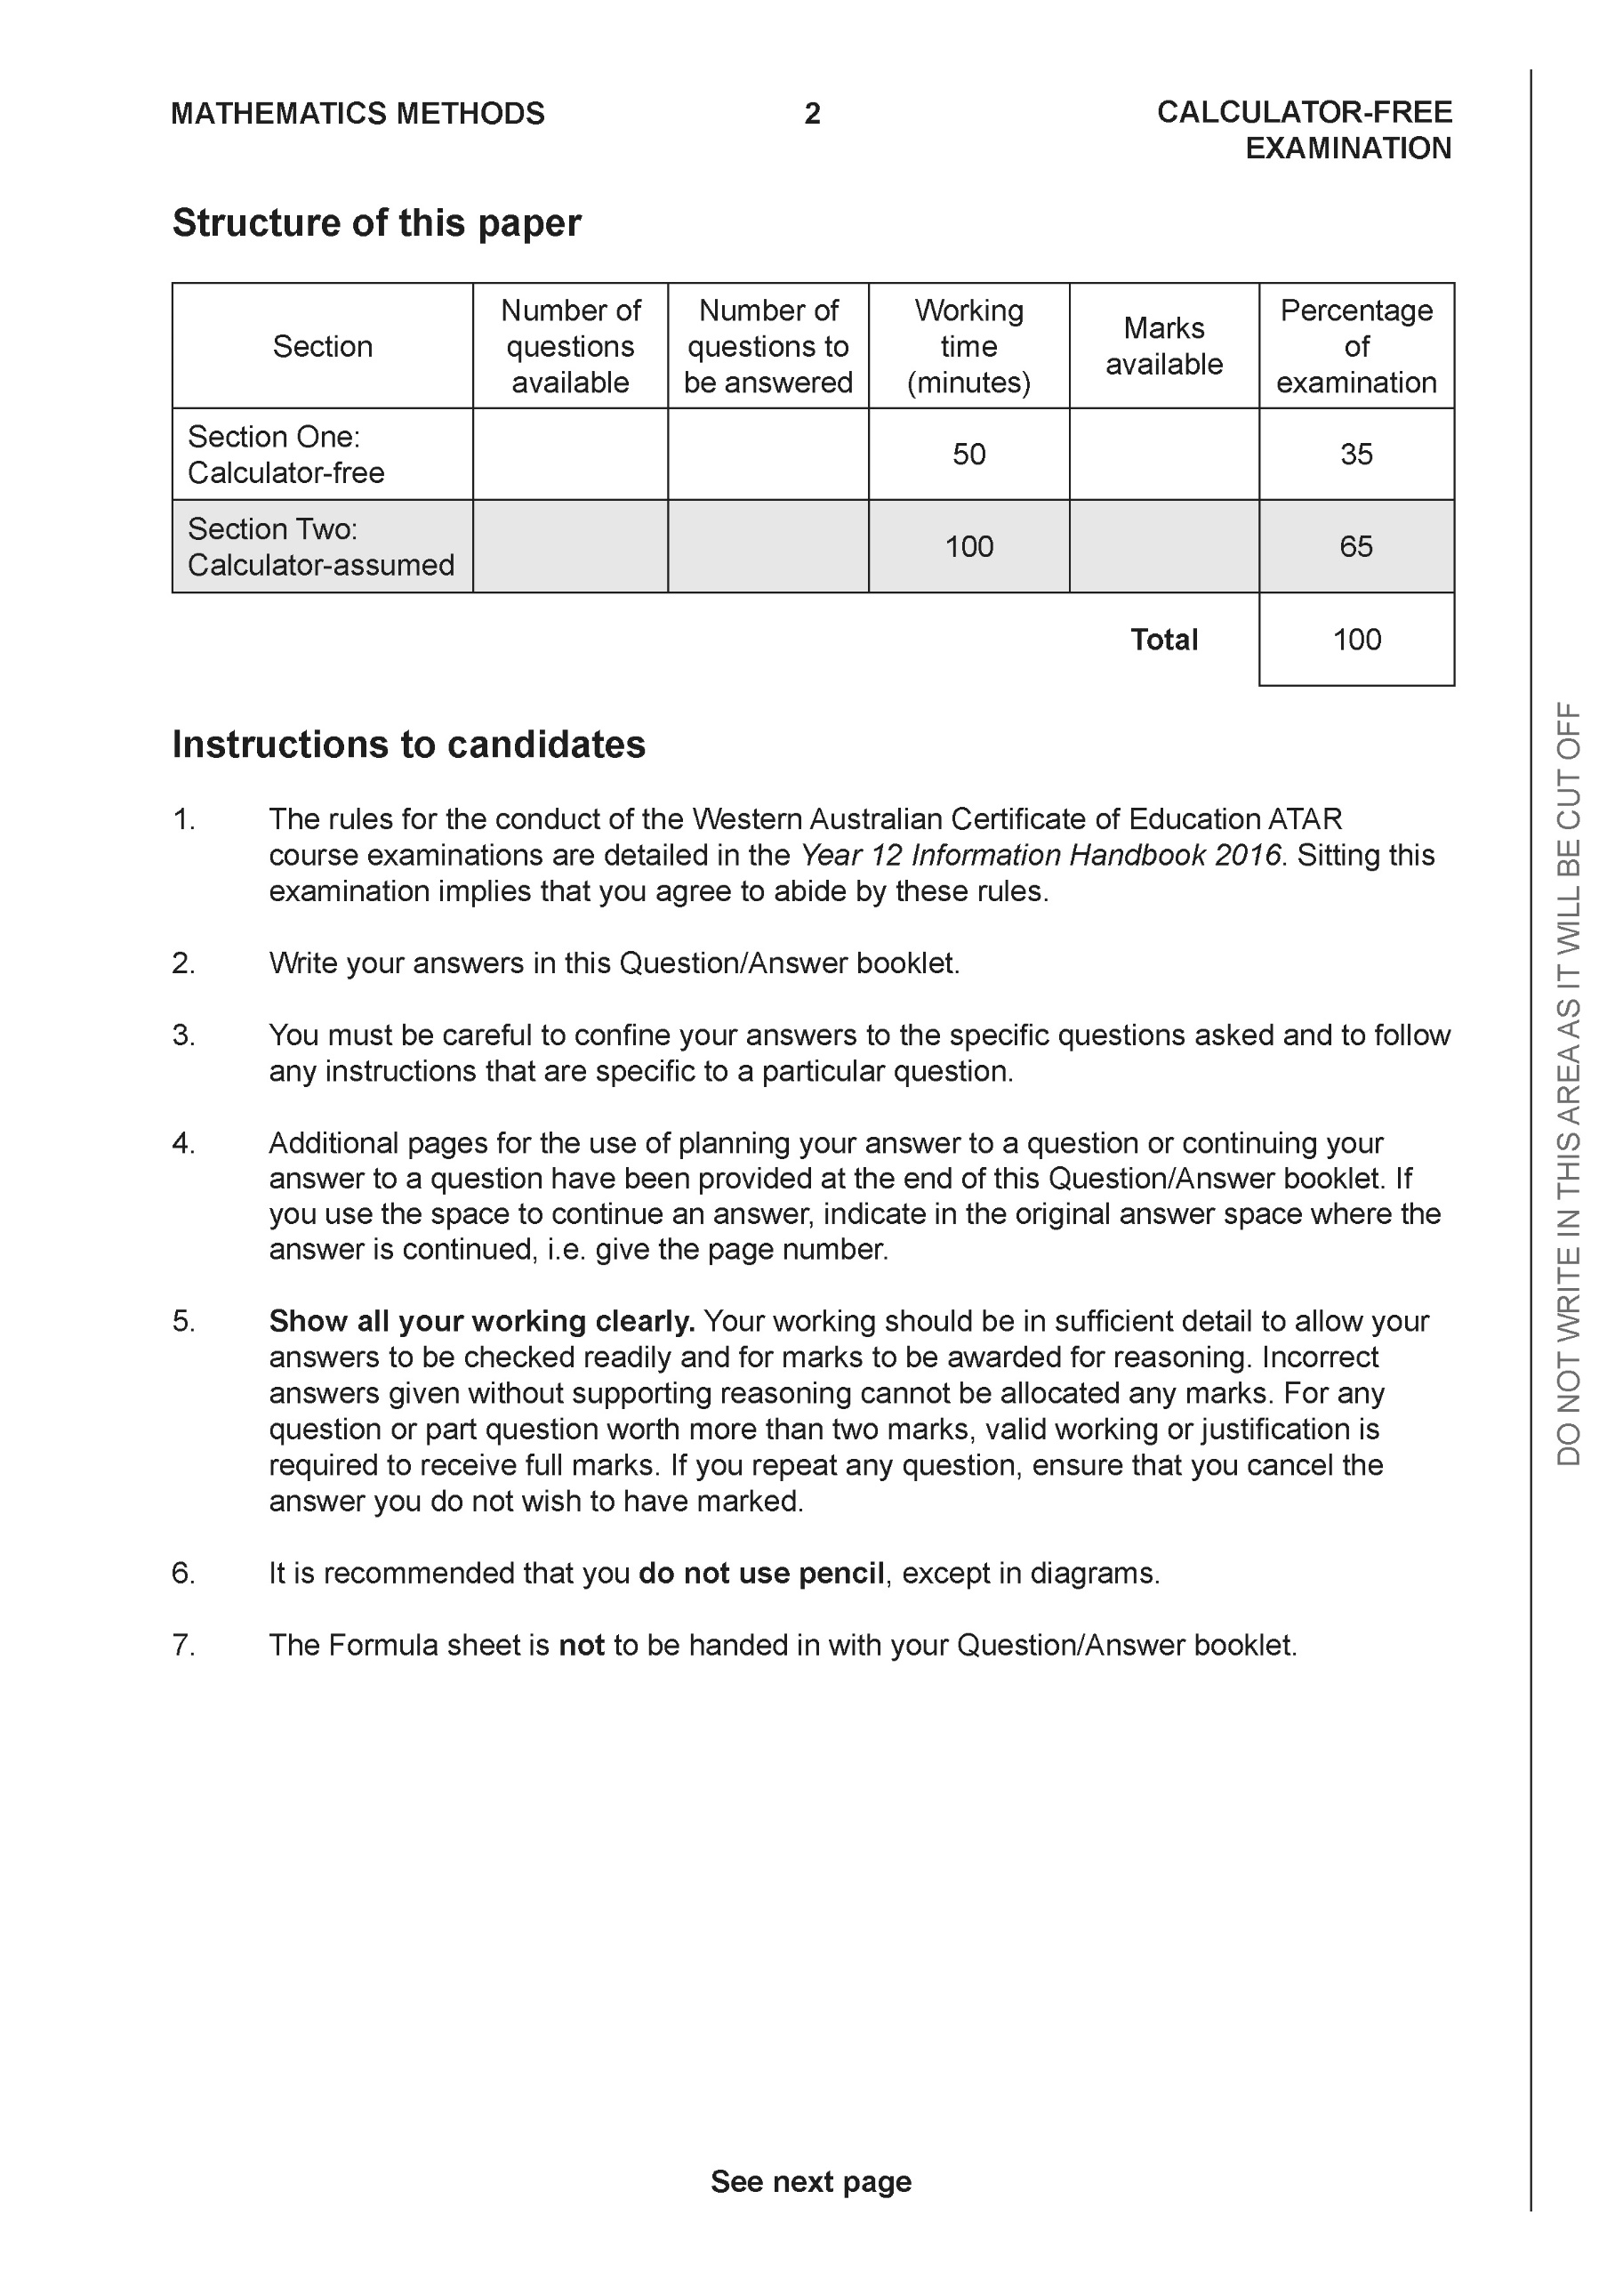

**Section One: Calculator-free (51 Marks)**

This section has **seven (7)** questions. Answer **all** questions. Write your answers in the spaces provided.

Spare pages are included at the end of this booklet. They can be used for planning your responses and/or as additional space if required to continue an answer.

● Planning: If you use the spare pages for planning, indicate this clearly at the top of the page.

● Continuing an answer: If you need to use the space to continue an answer, indicate in the original answer space where the answer is continued, i.e. give the page number. Fill in the number of the question that you are continuing to answer at the top of the page.

Working time: 50 minutes.

**Question 1 (6 marks)**

Let  and .

Determine:

1. the natural domain and range of . (2 marks)
2.  (1 mark)
3. the natural domain and range of  (3 marks)

**Question 2 (6 marks)**

Consider the following system of linear equations.



1. Solve for . (3marks)
2. For the following system where  are constants, determine

the possible values of for i) no solutions

ii) infinite solutions. (3 marks)

**Question 3 (12 marks)**

Determine the following integrals.

1.  using  (3 marks)
2.  (3 marks)
3.  (3 marks)

d) (3 marks)

**Question 4 (6 marks)**

1. Express the following expression into partial fractions  (3 marks)
2. Hence evaluate  (Do not simplify) (3 marks)

**Question 5 (9 marks)**

Consider a plane that contains the following points, .

1. Determine a vector equation for all points in the plane above. (3 marks)
2. Determine the distance of point  from the plane in part a. (3 marks)

(Do **not** simplify)

1. Determine the cosine of the angle that the line  makes with the plane in . (3 marks)

**Question 6 (7 marks)**

Consider the logistical model defined by  where  are positive constants.

1. Determine the value of ,  ,where . Explain the significance of this value.

(2 marks)

1. Derive the logistical formula  showing steps in your working. (5 marks)

**Question 7 (5 marks)**

Evaluate the following integral  showing all working. (Simplify)

**End of section one**

**Acknowledgements**